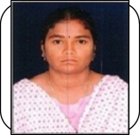
PERSONAL PROFILE

Name : REMANDLA PRASANTHI
Designation : GUEST FACULTY
College Address: SRR & CVR GDC (A), MACHAVARAM , VJA Cell No: 7386221331
Mail Id: rprasanthi1984@gmail.com

Educational Qualifications

S.NO | COURSE | BOARD /  UNIVERSITY | YEAR OF PASS | PERCENTAGE
1 | M.Com (Marketing) | Acharya Nagarjuna University | 2006 | 68%
2 | B.Com(Tax) | Acharya Nagarjuna  University | 2004 | 69%
3 | Intermediate(CEC) | Board of Intermediate | 2001 | 70%
4 | SSC | Board Of Secondary Education | 1999 | 75%

Professional Experience:
1. Worked as lecturer in Commerce

